16 September 2024 postcard

Great day today!

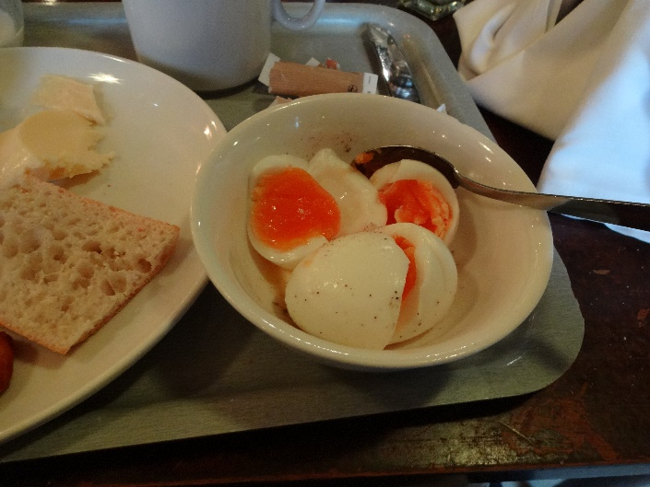

For breakfast yesterday, I boiled myself a couple of eggs in the breakfast room's seething cauldron, supplied for the purpose. You put each egg in a little wire basket that you then hang on the the wall of the boiling chamber. Each basket is numbered so you can keep track of which is yours. Not only did I get the timing right, but the eggs themselves were superb! So I did it again this morning, with the same result. Look at the color of those yolks! These tasted like the boiled eggs of my youth, from our own hens, who were fed commercial feed but supplemented with lots of garden trimmings, kitchen waste, and whatever they could scratch from the soil of the chicken yard (rich with earthworms and other goodies). Salt, pepper, and butter, and they were ambrosial.

Nobody even claimed they were organic, just "fresh," and the ease with which they peeled makes me doubt even that, but whatever those hens were fed, I wish American farmers would use!

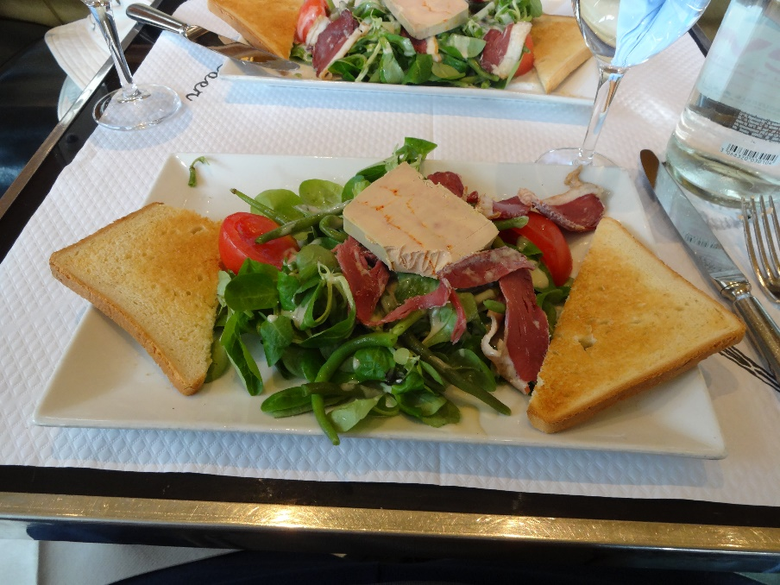We set out as usual at 11:30 am, on the #9 metro, for Trocadero, the complex of buildings and gardens across the Seine from the Eiffel Tower (Olympics ground zero). The whole area is chock-a-block with places to eat, so for lunch, we settled at the Café Kleber, where we found the salad we'd been looking for, the Landaise: greens (in this case, mâche, aka lamb's lettuce, and nothing else), tomatoes, cold green beans, slices of cured duck breast, a slab of cold foie gras, and toasts. All generously drizzled with a great mustard vinaigrette. The toasts were a disappointment—American-style sliced bread—so I ignored them and used the chunks of crusty baguettes that were brought to every table instead. Everything else was great!

For dessert, we split a serving of warm folded crêpes topped with sweetened cream of chestnuts. Mmm.

After pausing briefly to admire the view of the Eiffel Tower, we presented ourselves at the Musée de la Marine (one of the several branches of France's national maritime museum), in the same building as the Musée de l'Homme, which which we had to skip a couple of days ago.

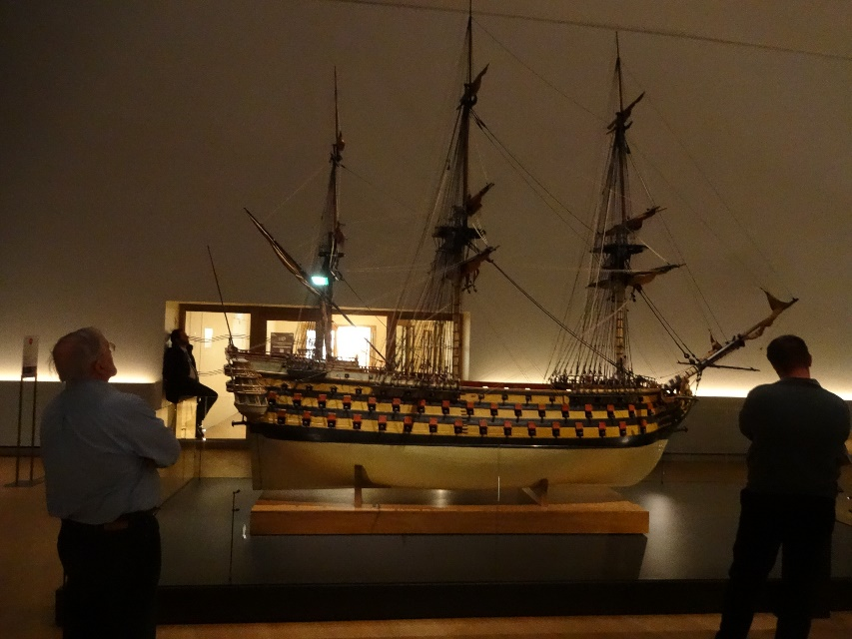What a great museum! Clearly newly renovated and crammed with interesting stuff. Plenty of benches and stools for resting our feet. And if you're into model ships, this is the place for you. I never saw so many, from 2 inches long up to maybe 15 feet, some cut away to show interior structure, submarines with glass outer walls so you to see inside. One with all the sails and rigging labeled. Did you know that the quantity of hemp in a three-masted 18th century sailing ship (caulking, rigging, hammocks, sails, other rope) was equal to the weight of four right whales? We'd covered maybe half of it when we gave up and came back to clean up for dinner. We'll definitely have to go back there.

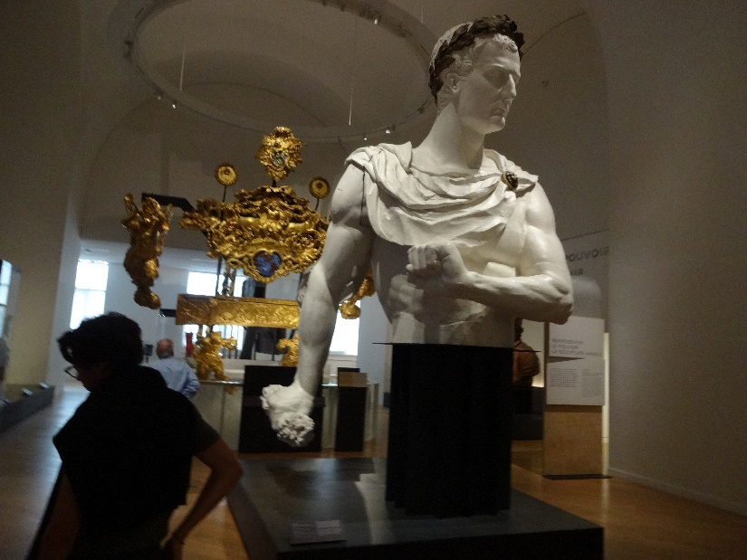

This gigantic figurehead is intended to be Napoleon.

Dinner at Chiberta, right by the Arc de Triomphe, originally one of Guy Savoy's places but since handed over to his protégé Clément Leroy. Last time we were there, I had one of the best oyster dishes of my life, but I don't see it on this year's menu.

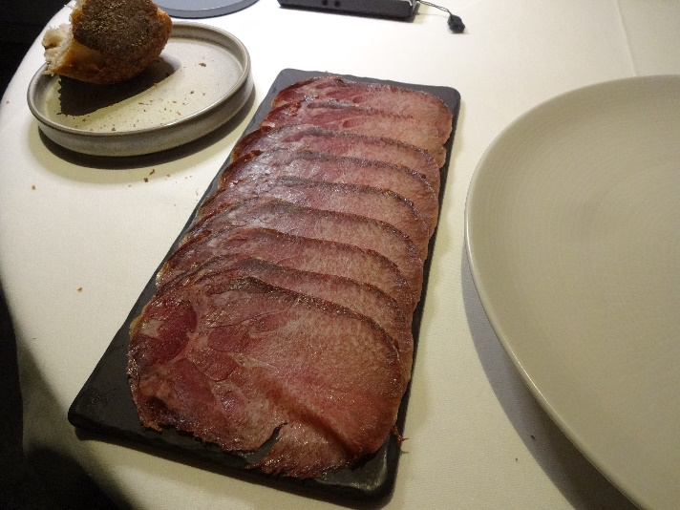This is my starter, ham of beef tongue (one of the specials for the evening, and not something you see often!). The portion looks huge in the photo, but the slices were extremely thin, and I polished it off in no time. I offered David a bite, but he shuddered and said it would give him nightmares.

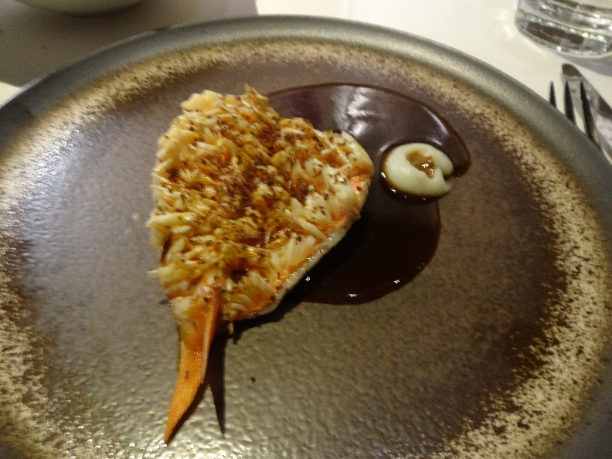

And here's my fish course: A single rouget-barbet split up the ventral side and flattened, with the scales on, then cooked on a blisteringly hot griddle, scaly side down, so that the scales stood up to attention, lifting the whole thing off the surface (and therefore protecting the flesh from overcooking) and becoming so toasted and crisp and you could munch them right down. It was served skin-side up—you can see all those crispy scales standing up all over the surface. When I finished, nothing was left on the plate but a smear of sauce and the tiny pink tail.